Timetable APP
by
Andrè Muscat & Kyle Zammit

The APP idea:
The app idea we have decided on is a Timetable app in which the user can mark certain times during the day and list activities and tasks. The app can change the number of days shown in the table as well as displaying it in either a daily, weekly or monthly view for different layouts. The user will be able to add, delete, modify and upload an image to any timeslot. The toolbar menu will allow the user to change between different timetables for different activities, as well as being able to change other settings such as alarms and notifications. Statistics about the user’s profile will also be available to view, and the user will be able to download those statistics as well as the timetable itself as an excel file using SQlite.

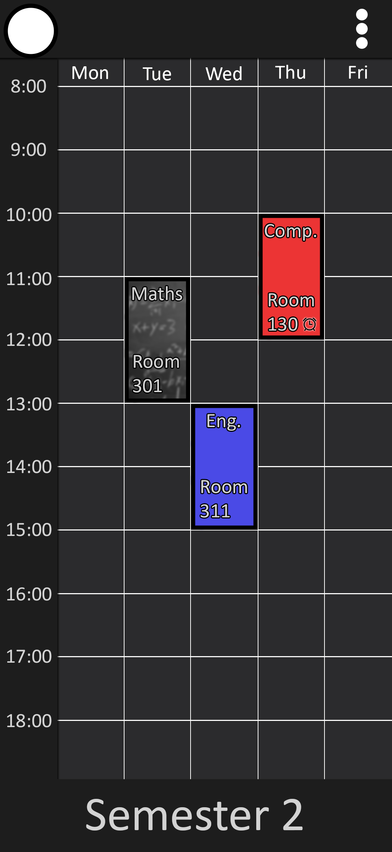
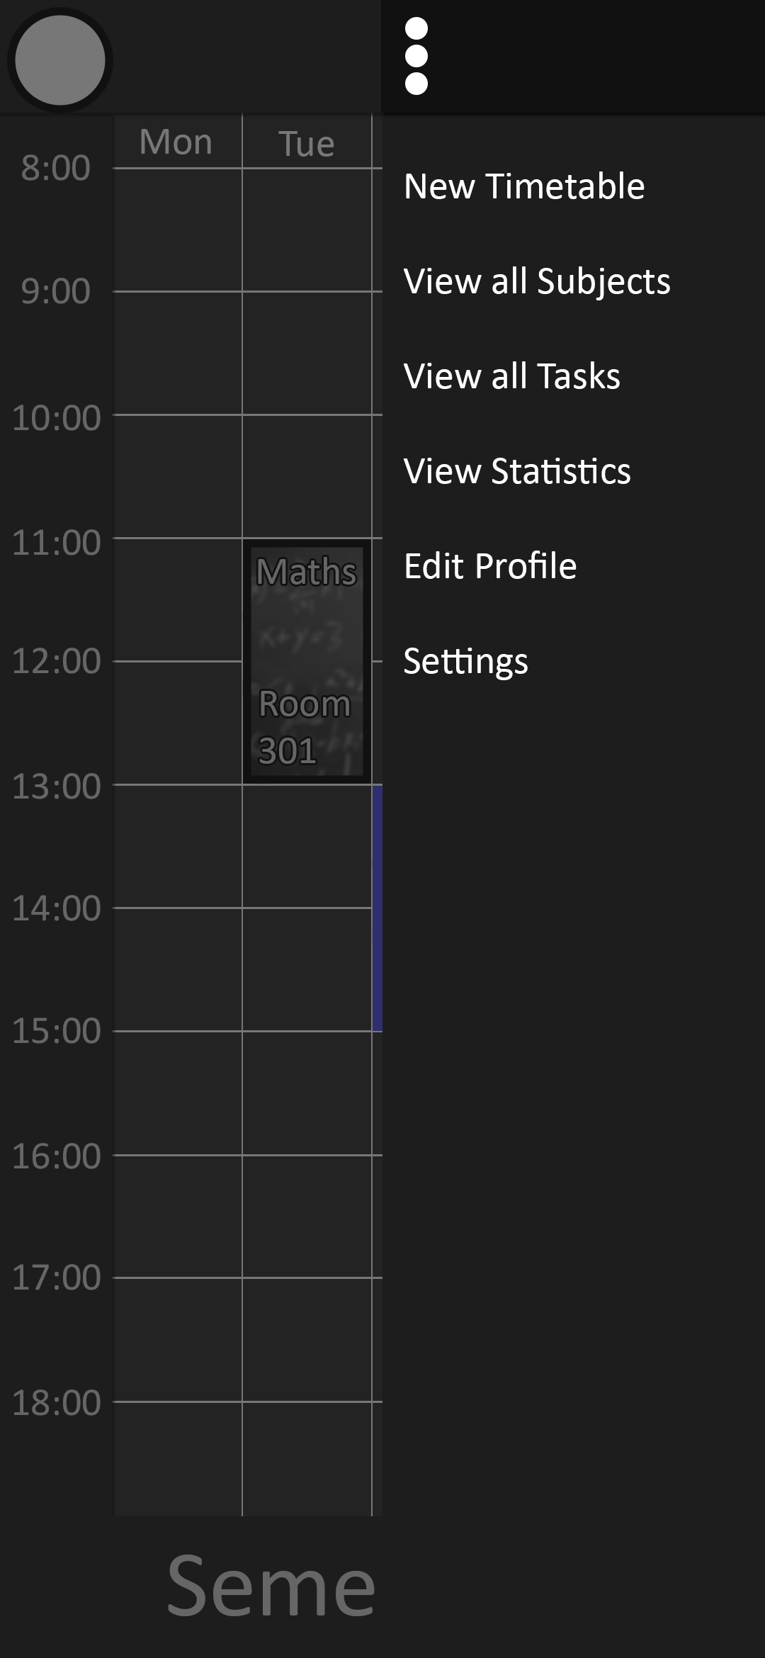
The initial Design
